Landscape Monitoring Framework Estimates By Ecoregion
10/7/2020

Figure 1: Proportion of BLM rangelands with none-to-slight or slight-to-moderate departure from biotic integrity reference conditions (BI <=2) (80% confidence interval)
## Warning: Removed 22 rows containing missing values (geom_bar).
## Warning: Removed 65 rows containing missing values (geom_point).
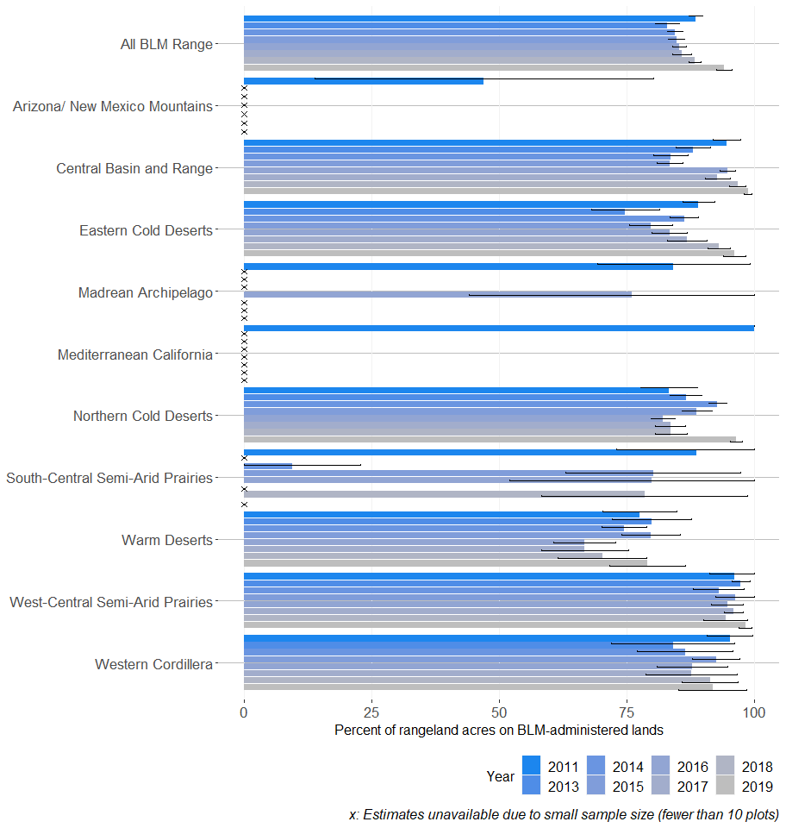

Figure 2: Proportion of BLM rangelands with moderate departure from biotic integrity reference conditions (BI = 3) (80% confidence interval)
## Warning: Removed 22 rows containing missing values (geom_bar).
## Warning: Removed 65 rows containing missing values (geom_point).
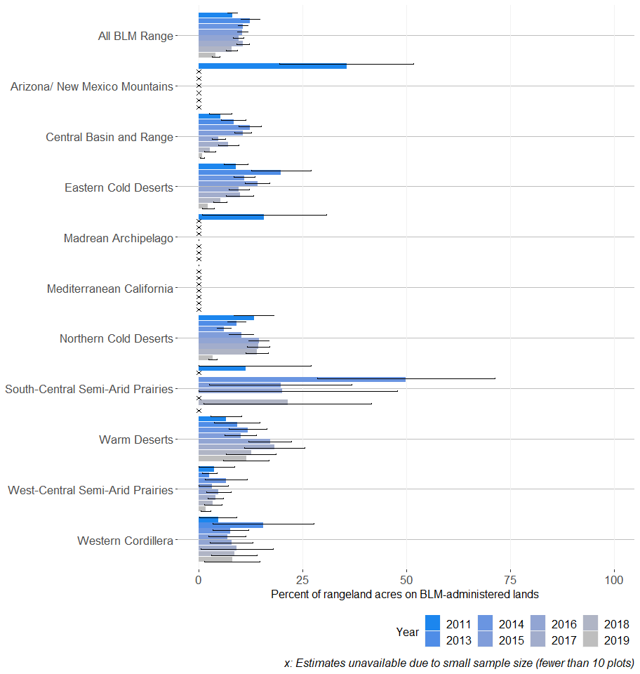

Figure 3: Proportion of BLM rangelands with moderate or moderate-to-extreme or extreme-to-total departure from biotic integrity reference conditions (BI >=3) (80% confidence interval)
## Warning: Removed 22 rows containing missing values (geom_bar).
## Warning: Removed 65 rows containing missing values (geom_point).
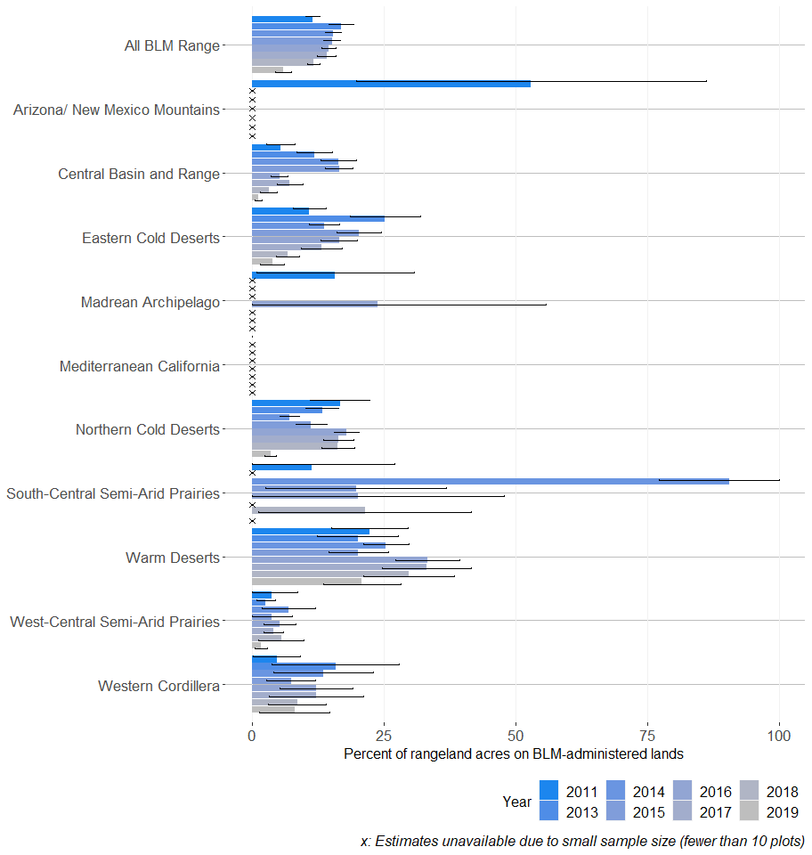

Figure 4: Proportion of BLM rangelands with moderate-to-extreme or extreme-to-total departure from biotic integrity reference conditions (BI >= 4) (80% confidence interval)
## Warning: Removed 22 rows containing missing values (geom_bar).
## Warning: Removed 65 rows containing missing values (geom_point).
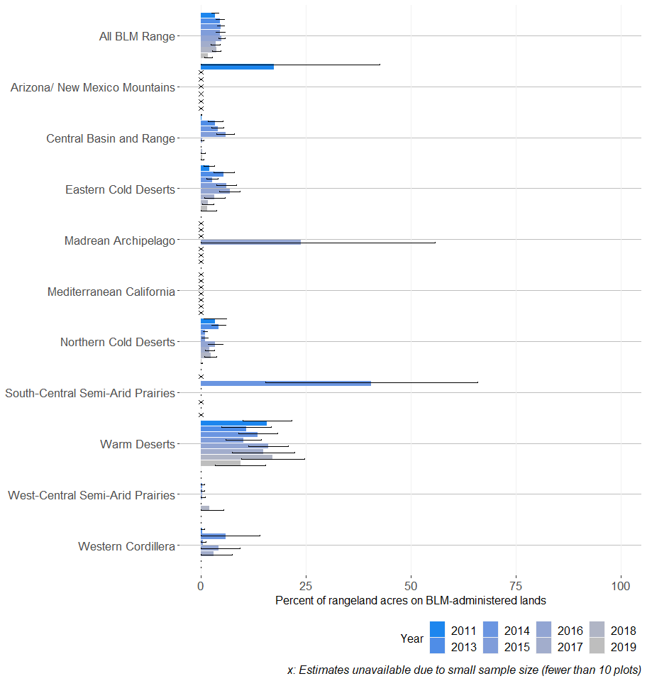

Figure 5: Proportion of BLM rangelands with none-to-slight or slight-to-moderate departure from hydrologic function reference conditions (HF <=2) (80% confidence interval)
## Warning: Removed 22 rows containing missing values (geom_bar).
## Warning: Removed 65 rows containing missing values (geom_point).
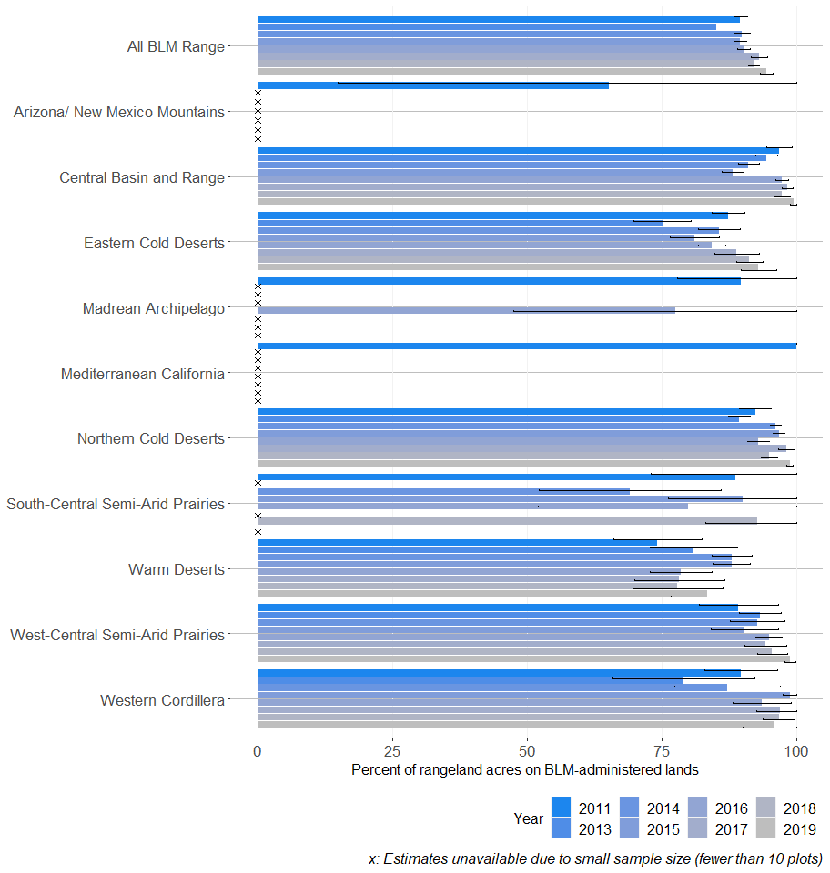

Figure 6: Proportion of BLM rangelands with moderate departure from hydrologic function reference conditions (HF = 3) (80% confidence interval)
## Warning: Removed 22 rows containing missing values (geom_bar).
## Warning: Removed 65 rows containing missing values (geom_point).
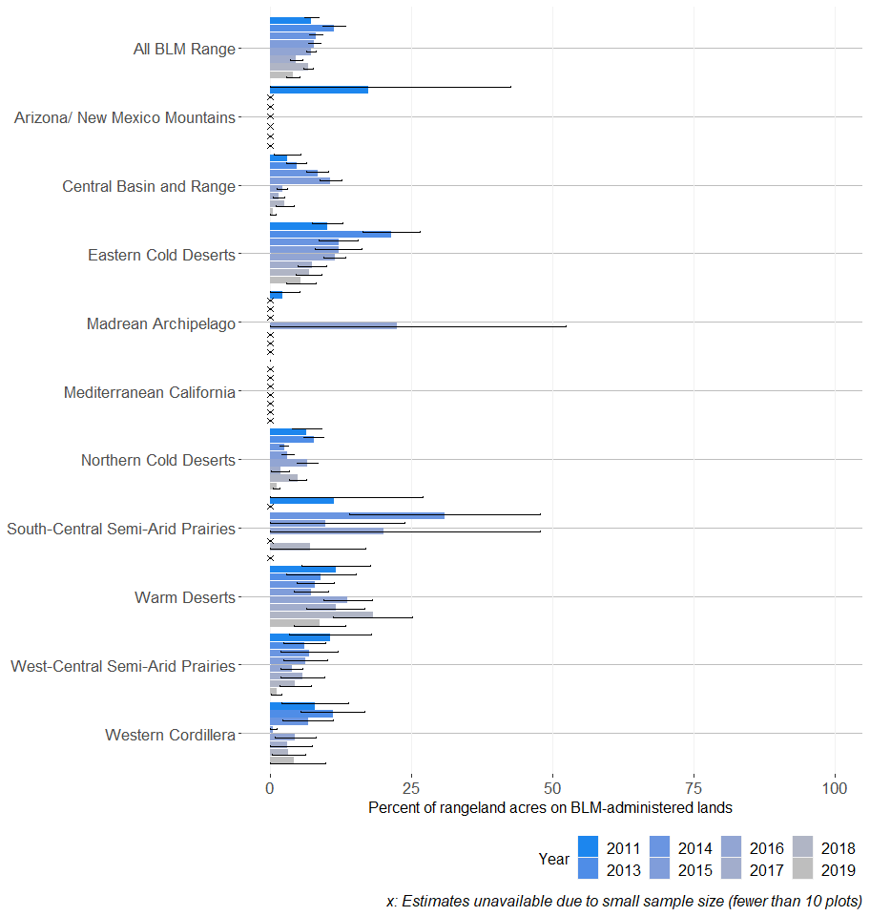

Figure 7: Proportion of BLM rangelands with moderate or moderate-to-extreme or extreme-to-total departure from hydrologic function reference conditions (HF >= 3) (80% confidence interval)
## Warning: Removed 22 rows containing missing values (geom_bar).
## Warning: Removed 65 rows containing missing values (geom_point).
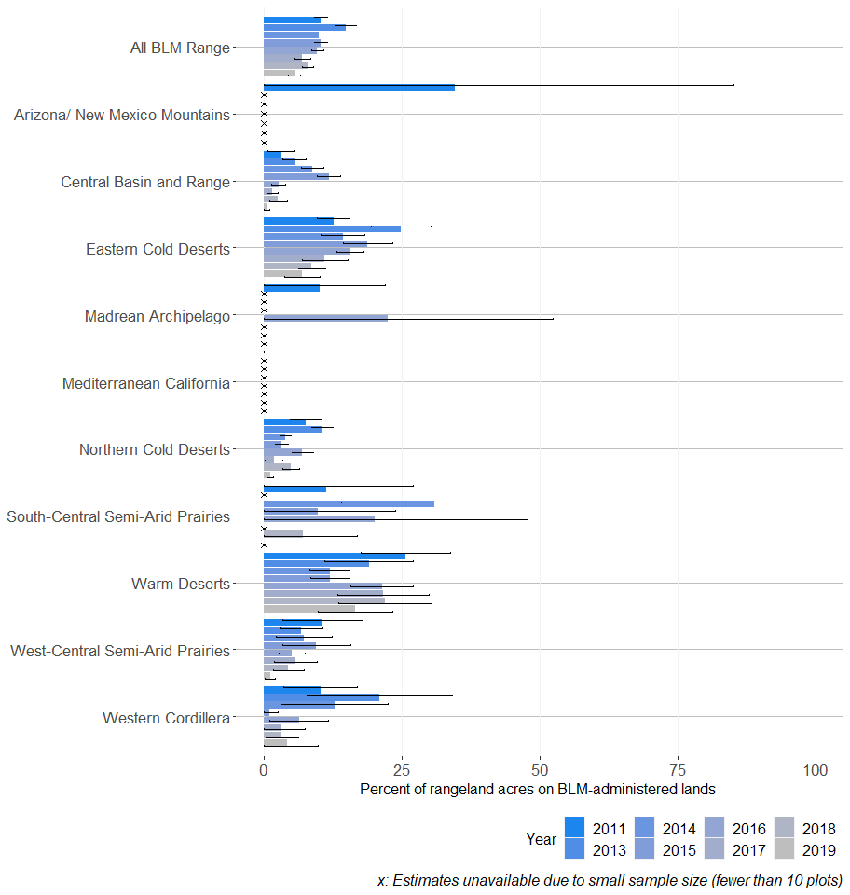

Figure 8: Proportion of BLM rangelands with moderate-to-extreme or extreme-to-total departure from hydrologic function reference conditions (HF >= 4) (80% confidence interval)
## Warning: Removed 22 rows containing missing values (geom_bar).
## Warning: Removed 65 rows containing missing values (geom_point).
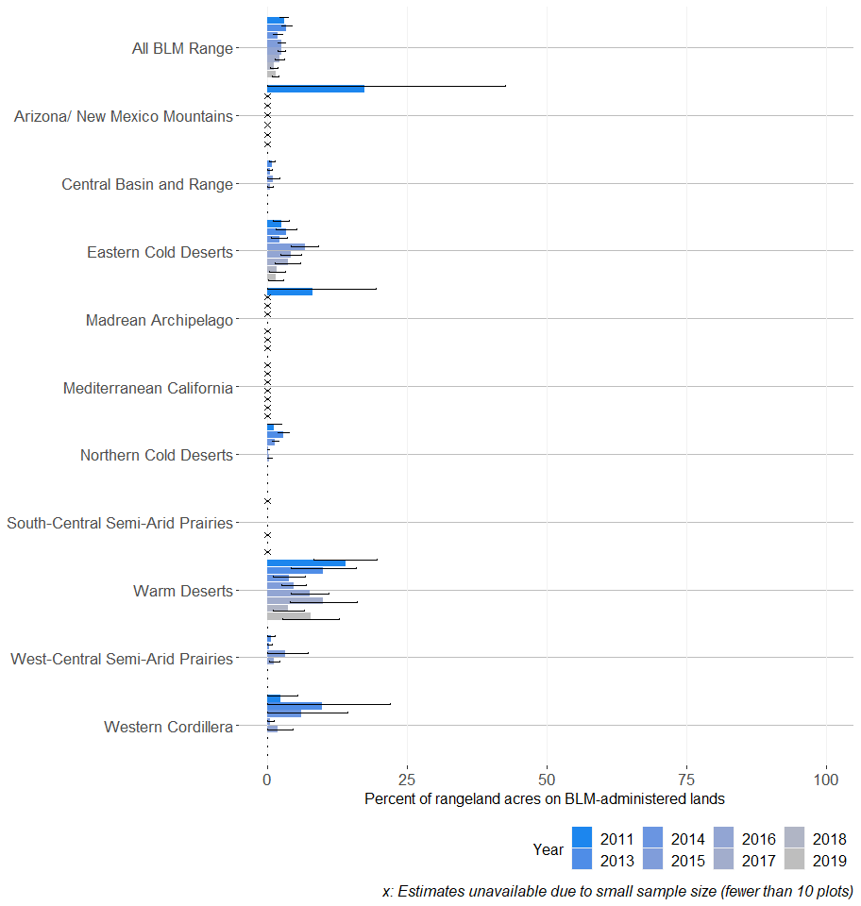

Figure 9: Proportion of BLM rangelands with none-to-slight or slight-to-moderate departure from soil and site stability reference conditions (SSS <=2) (80% confidence interval)
## Warning: Removed 22 rows containing missing values (geom_bar).
## Warning: Removed 65 rows containing missing values (geom_point).
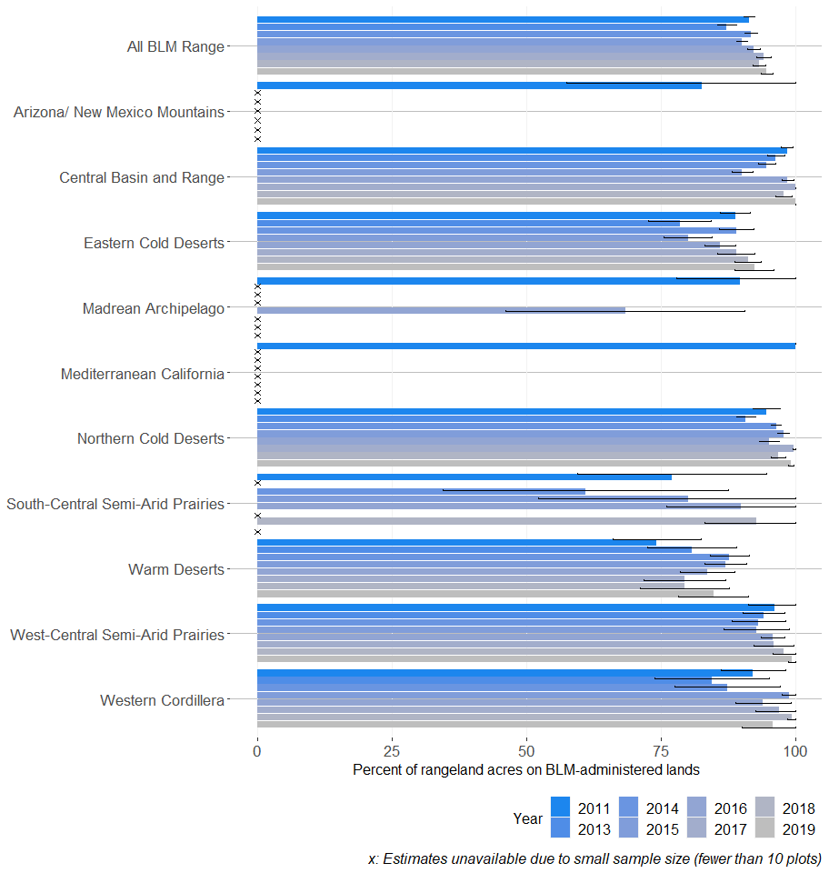

Figure 10: Proportion of BLM rangelands with moderate departure from soil and site stability reference conditions (SSS = 3) (80% confidence interval)
## Warning: Removed 22 rows containing missing values (geom_bar).
## Warning: Removed 65 rows containing missing values (geom_point).
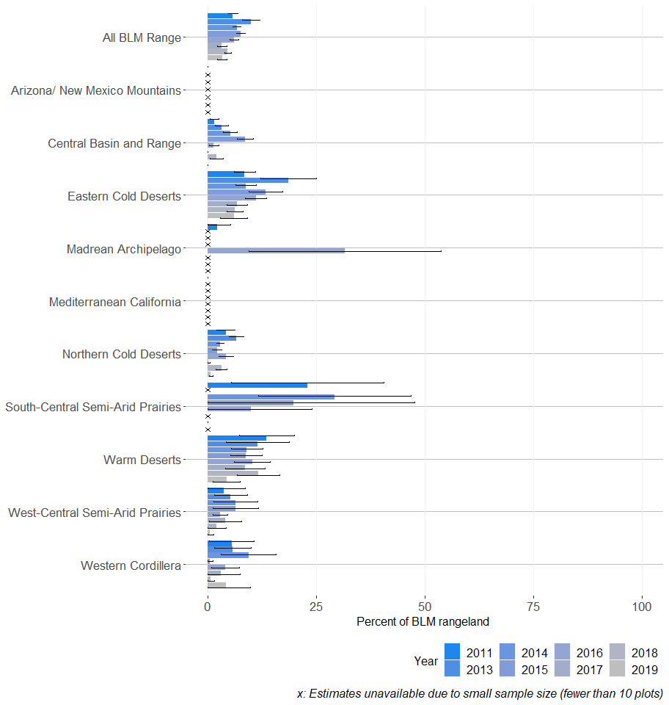

Figure 11: Proportion of BLM rangelands with moderate or moderate-to-extreme or extreme-to-total departure from soil and site stability reference conditions (SSS >= 3) (80% confidence interval)
## Warning: Removed 22 rows containing missing values (geom_bar).
## Warning: Removed 65 rows containing missing values (geom_point).
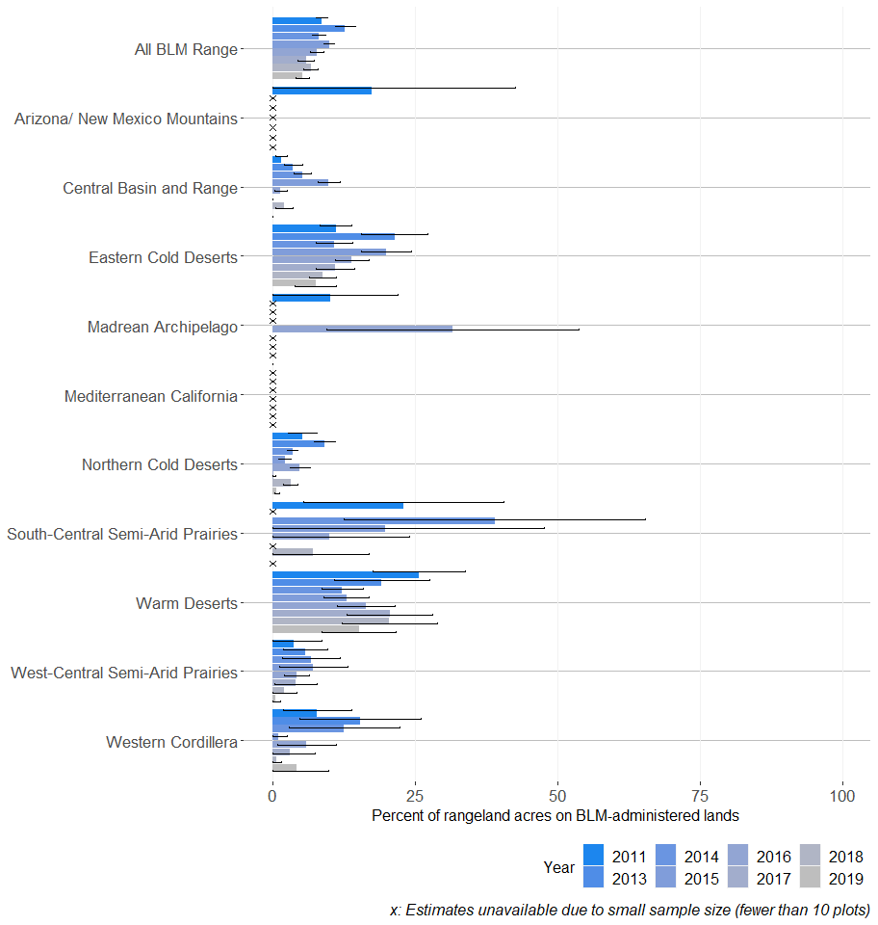

Figure 12: Proportion of BLM rangelands with moderate-to-extreme or extreme-to-total departure from soil and site stability reference conditions (SSS >= 4) (80% confidence interval)
## Warning: Removed 22 rows containing missing values (geom_bar).
## Warning: Removed 65 rows containing missing values (geom_point).
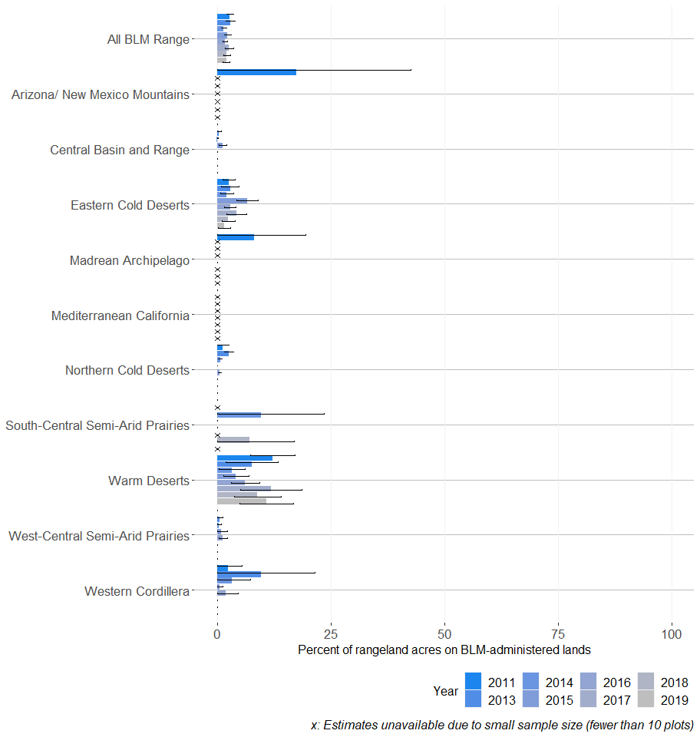

Figure 13: Proportion of BLM rangelands where all 3 rangeland health attributes had none-to-slight or slight-to-moderate departure from reference conditions (<= 2) (80% confidence interval)
## Warning: Removed 22 rows containing missing values (geom_bar).
## Warning: Removed 65 rows containing missing values (geom_point).
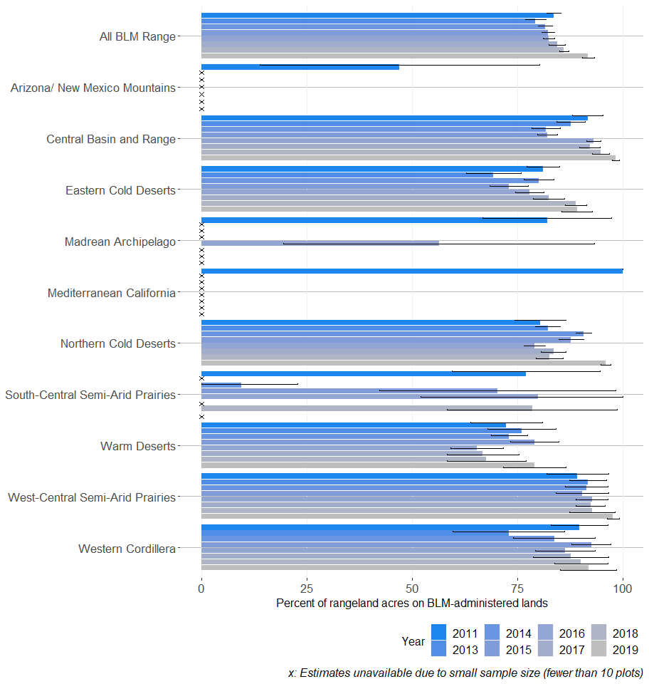

Figure 14: Proportion of BLM rangelands where all 3 rangeland health attributes had moderate-to-extreme or extreme-to-total departure from reference conditions (>= 4) (80% confidence interval)
## Warning: Removed 22 rows containing missing values (geom_bar).
## Warning: Removed 65 rows containing missing values (geom_point).
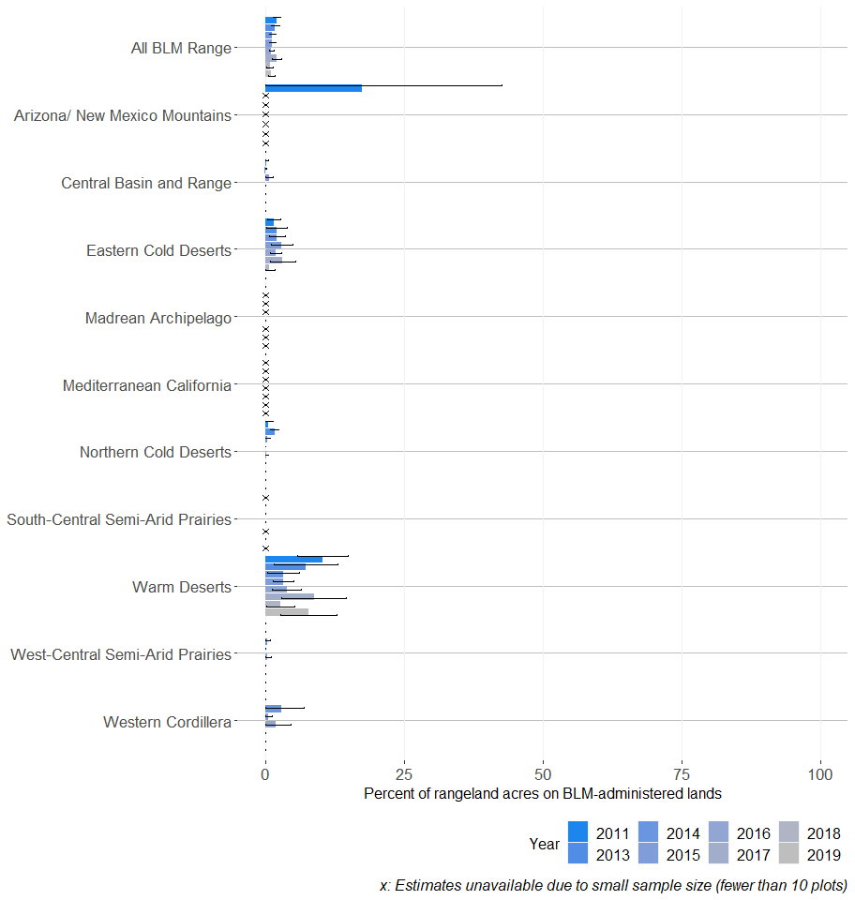

Figure 15: Proportion of BLM rangelands where at least 1 rangeland health attribute had moderate departure from reference conditions (= 3) (80% confidence interval)
## Warning: Removed 22 rows containing missing values (geom_bar).
## Warning: Removed 65 rows containing missing values (geom_point).
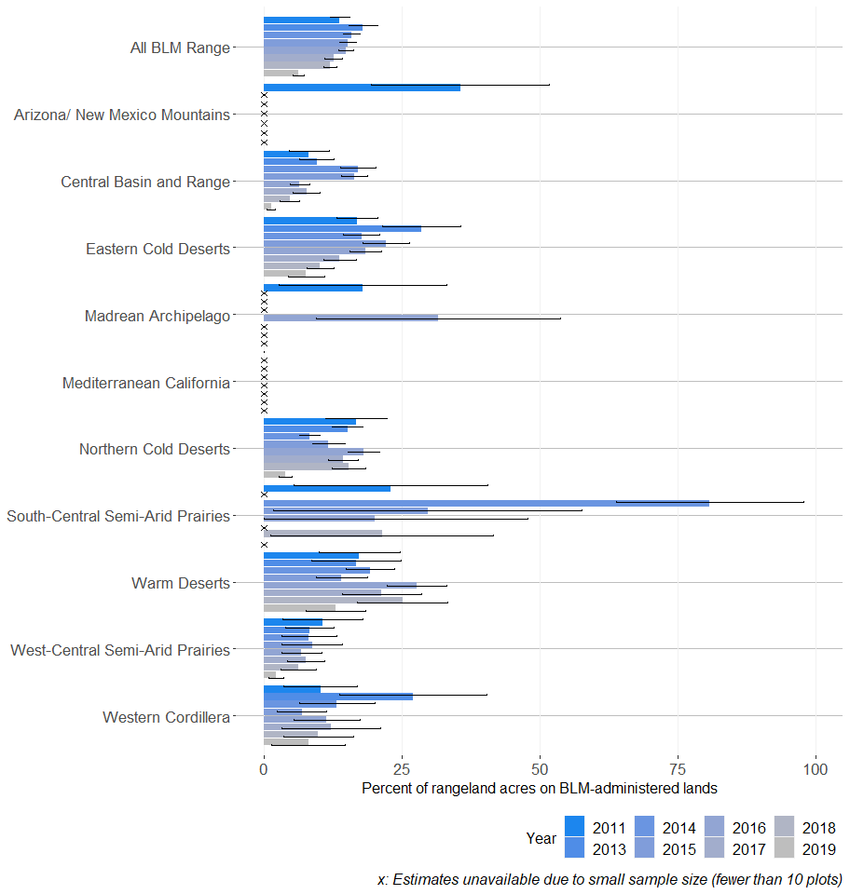

Figure 16: Proportion of BLM rangelands with non-native invasive species present (80% confidence interval)
## Warning: Removed 22 rows containing missing values (geom_bar).
## Warning: Removed 65 rows containing missing values (geom_point).
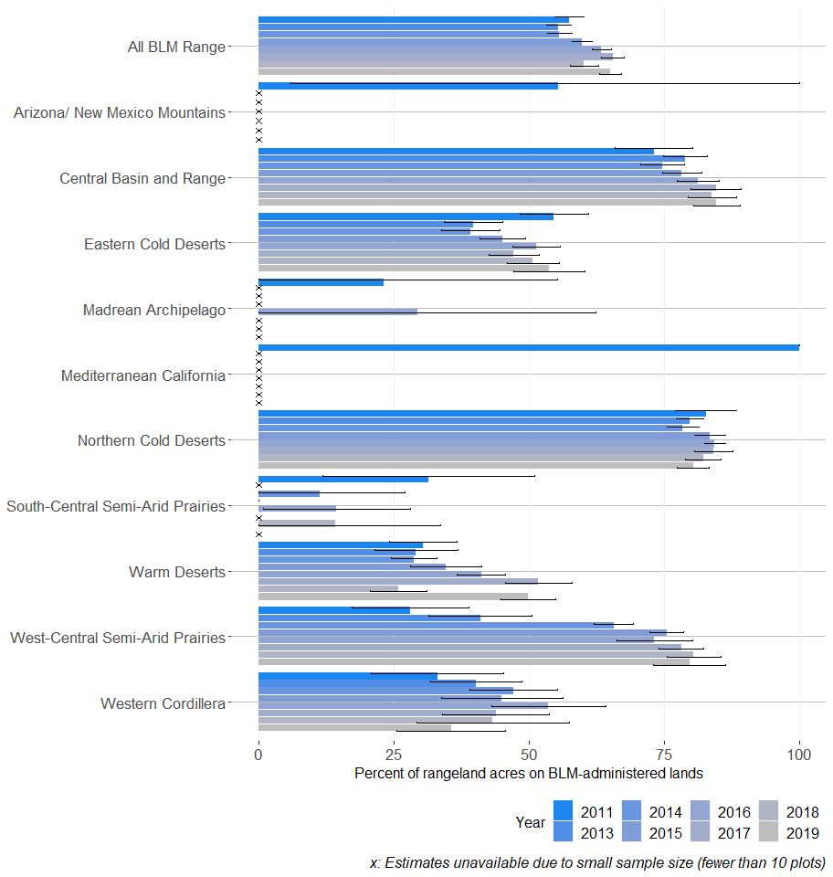

Figure 17: Proportion of BLM rangelands where non-native invasive species are abundant (>= 25%) (80% confidence interval)
## Warning: Removed 22 rows containing missing values (geom_bar).
## Warning: Removed 65 rows containing missing values (geom_point).
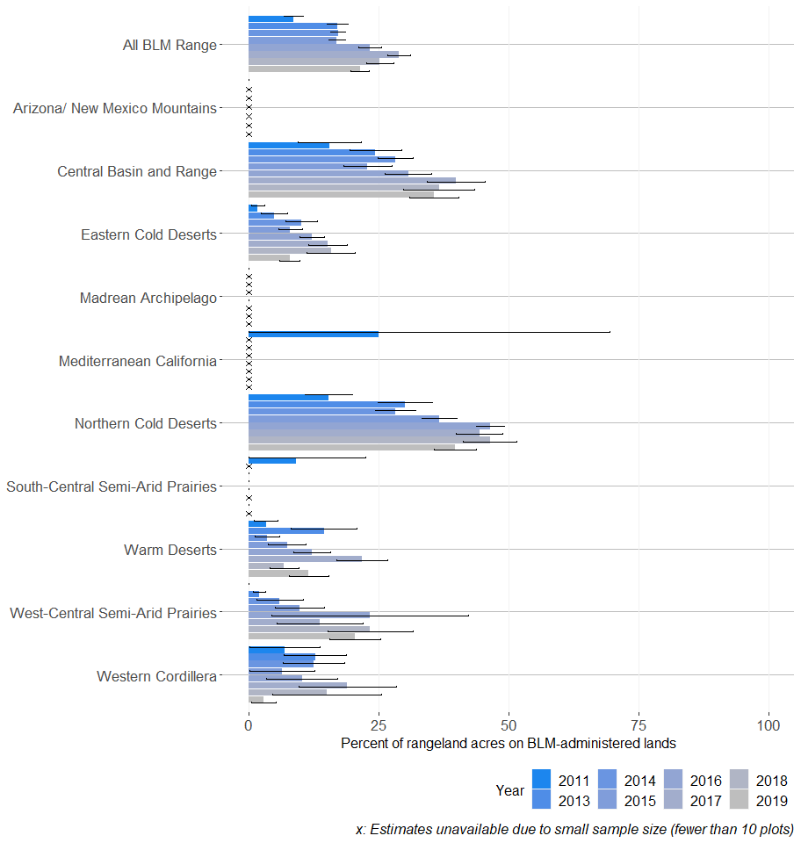

Figure 18: Proportion of BLM rangelands with at least 20% of land having intercanopy gaps of at least 2 meters (80% confidence interval)
## Warning: Removed 22 rows containing missing values (geom_bar).
## Warning: Removed 65 rows containing missing values (geom_point).
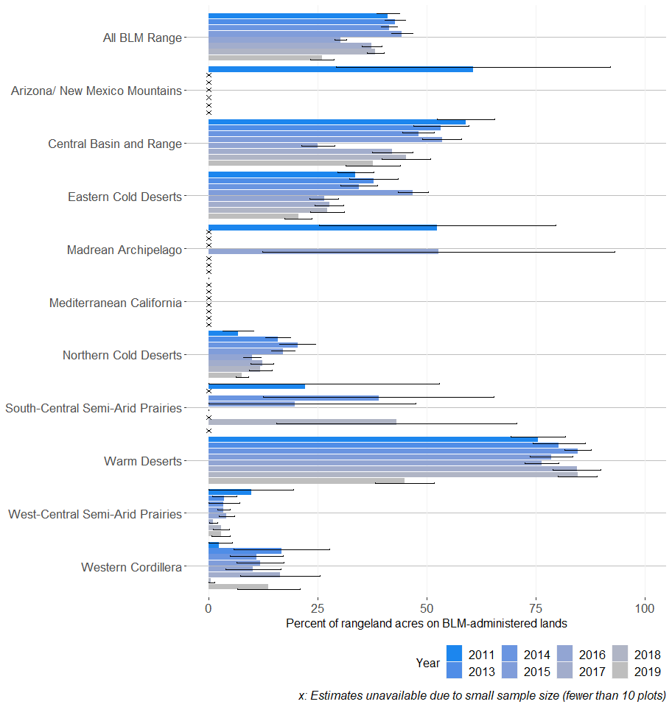

Figure 19: Proportion of BLM rangelands with at least 20% of land having intercanopy gaps of at least 2 meters and gaps are at least 50% bare ground (80% confidence interval)
## Warning: Removed 22 rows containing missing values (geom_bar).
## Warning: Removed 65 rows containing missing values (geom_point).
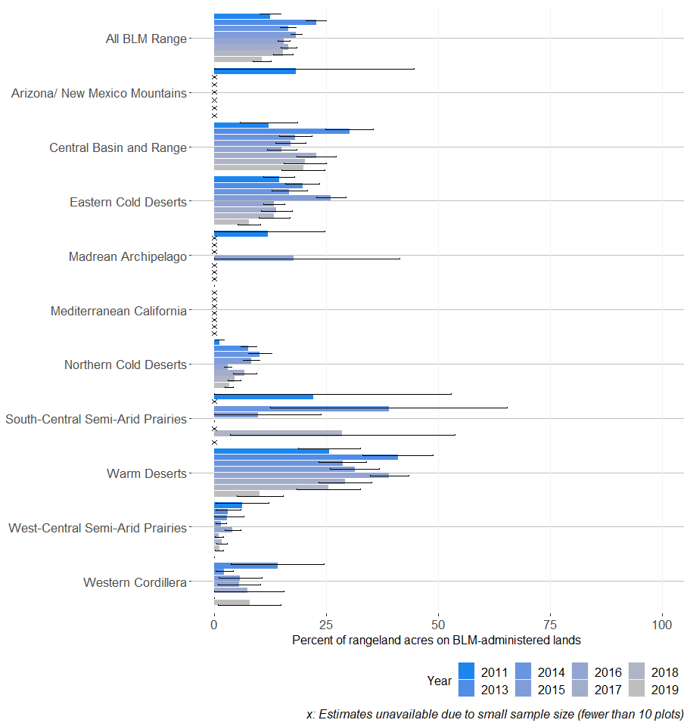

Figure 20: Percent cover of bare ground on BLM rangelands (80% confidence interval)
## Warning: Removed 22 rows containing missing values (geom_bar).
## Warning: Removed 54 rows containing missing values (geom_point).
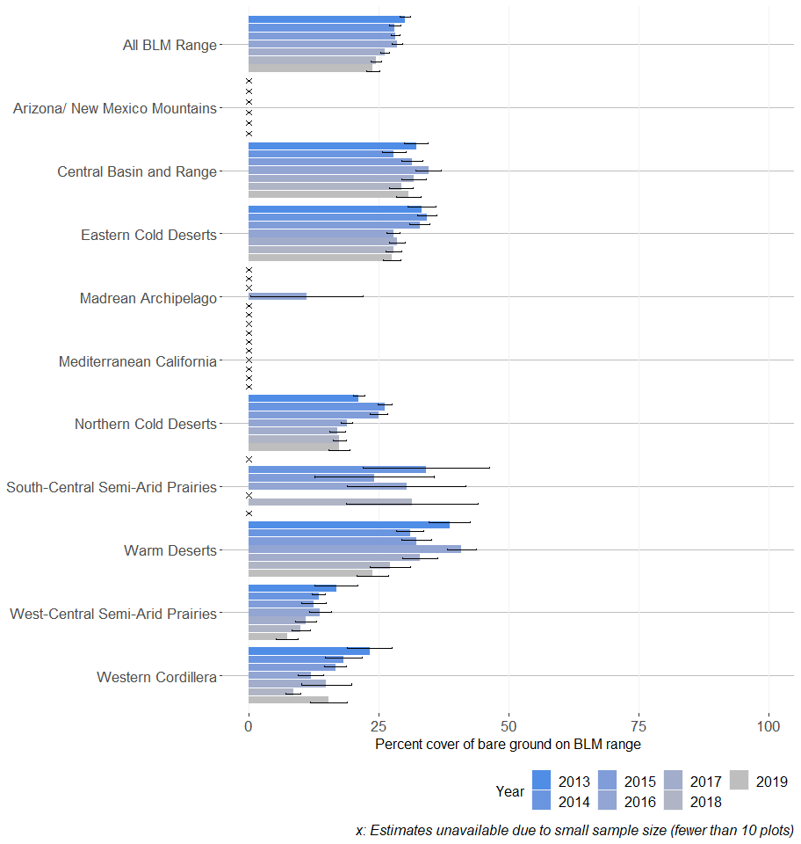

Figure 21: Proportion of BLM rangelands with at least 20% bare ground (80% confidence interval)
## Warning: Removed 22 rows containing missing values (geom_bar).
## Warning: Removed 65 rows containing missing values (geom_point).
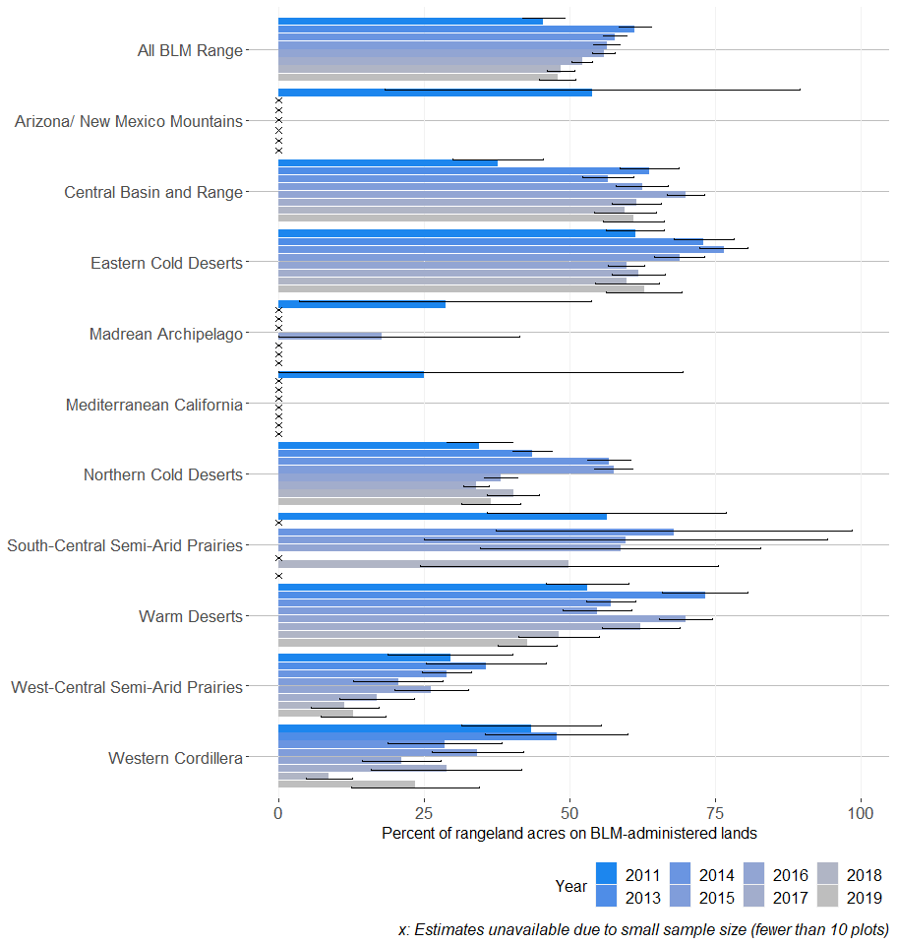

Figure 22: Proportion of BLM rangelands with at least 30% bare ground (80% confidence interval)
## Warning: Removed 22 rows containing missing values (geom_bar).
## Warning: Removed 65 rows containing missing values (geom_point).
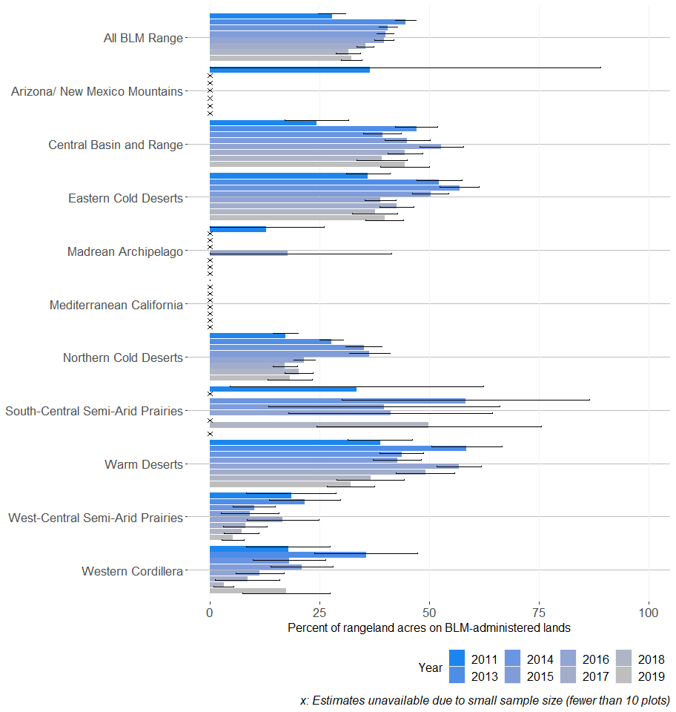

Figure 23: Proportion of BLM rangelands with at least 40% bare ground (80% confidence interval)
## Warning: Removed 22 rows containing missing values (geom_bar).
## Warning: Removed 65 rows containing missing values (geom_point).
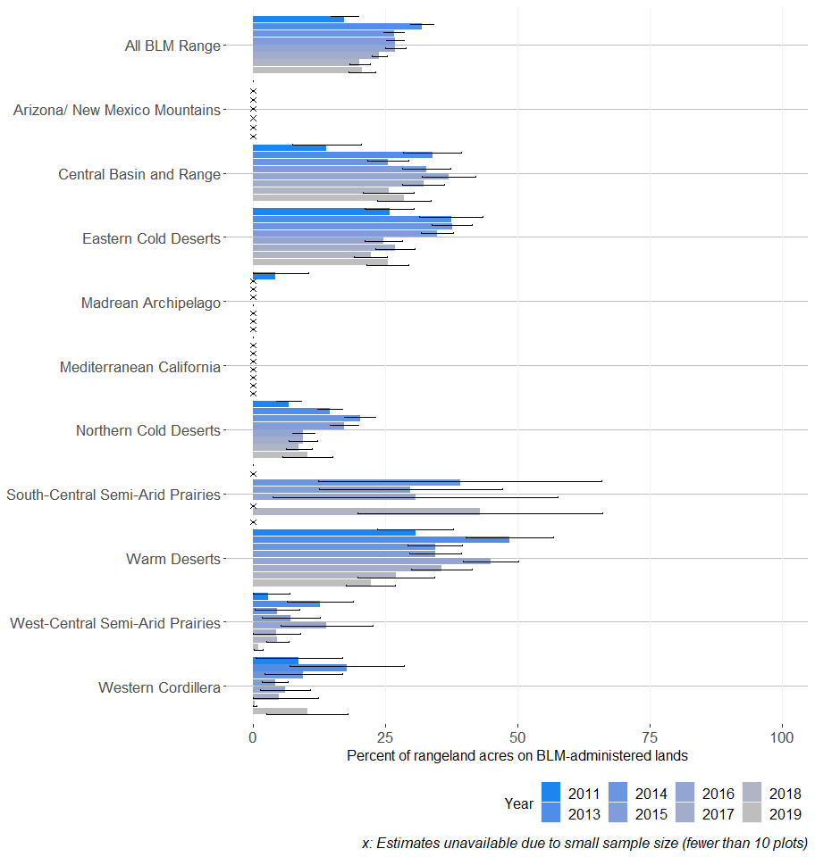

Figure 24: Proportion of BLM rangelands with at least 50% bare ground (80% confidence interval)
## Warning: Removed 22 rows containing missing values (geom_bar).
## Warning: Removed 65 rows containing missing values (geom_point).
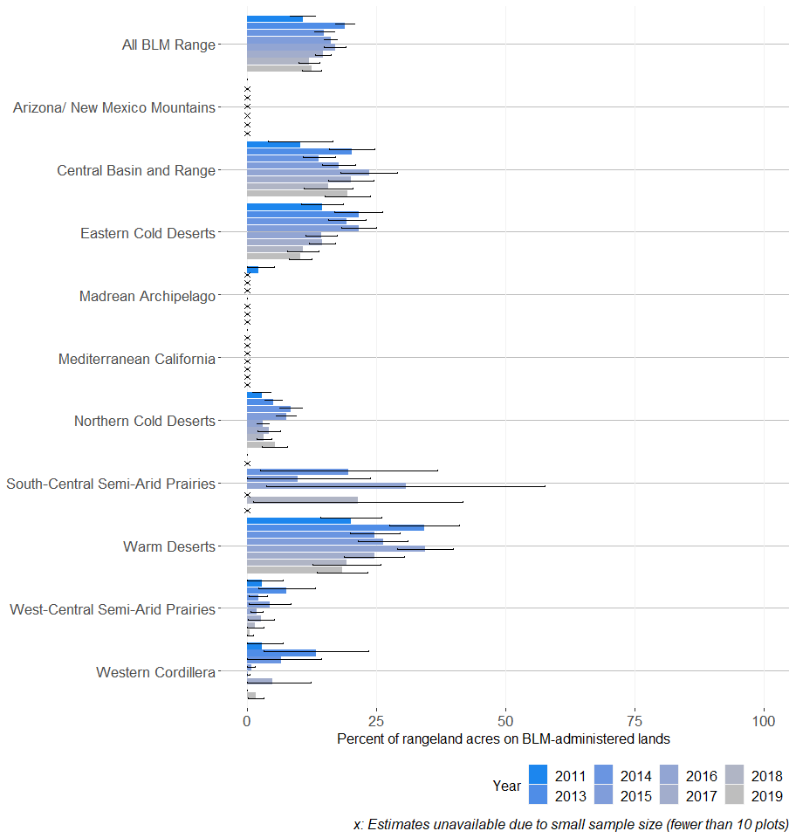

Figure 25: Proportion of BLM rangelands where soil aggregate stability is ranked 4 or less (80% confidence interval)
## Warning: Removed 18 rows containing missing values (geom_bar).
## Warning: Removed 58 rows containing missing values (geom_point).
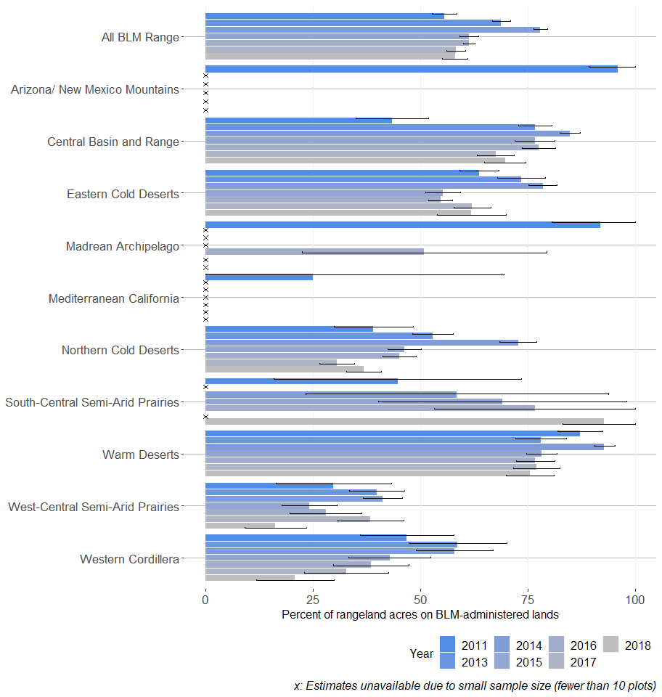

Figure 26: Percent cover of sagebrush on BLM rangelands (80% confidence interval)
## Warning: Removed 22 rows containing missing values (geom_bar).
## Warning: Removed 54 rows containing missing values (geom_point).
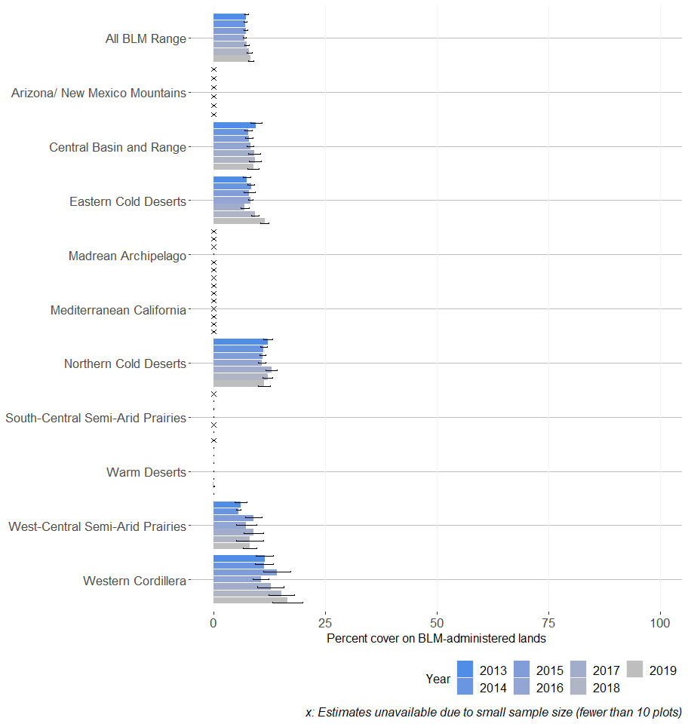

Figure 27: Mean sagebrush species height in inches on BLM rangelands (80% confidence interval)
## Warning: Removed 22 rows containing missing values (geom_bar).
## Warning: Removed 54 rows containing missing values (geom_point).
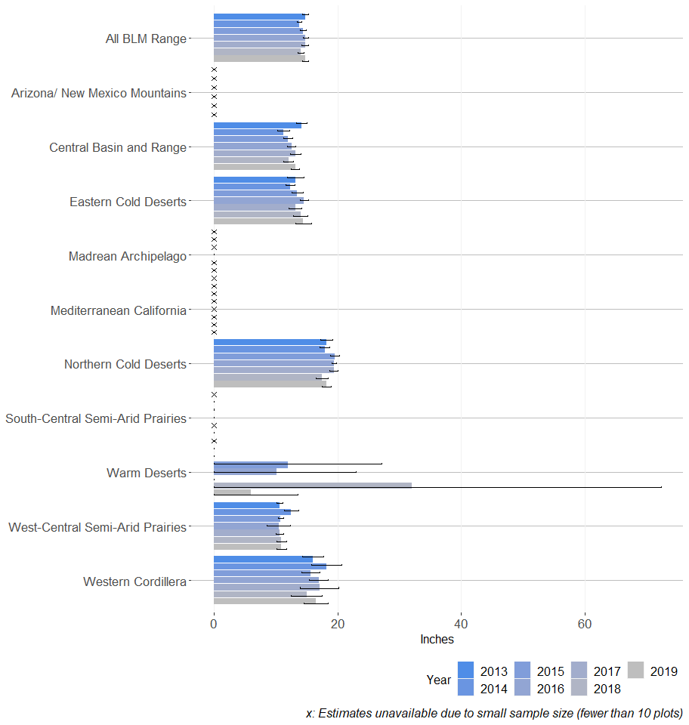

Figure 28: Proportion of sagebrush that is columnar shaped on BLM rangelands (80% confidence interval)
## Warning: Removed 22 rows containing missing values (geom_bar).
## Warning: Removed 54 rows containing missing values (geom_point).
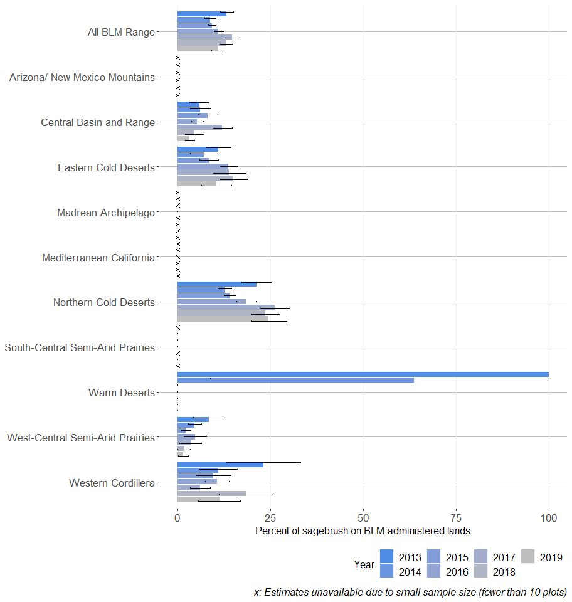

Figure 29: Proportion of sagebrush that is spreading shaped on BLM rangelands (80% confidence interval)
## Warning: Removed 22 rows containing missing values (geom_bar).
## Warning: Removed 54 rows containing missing values (geom_point).
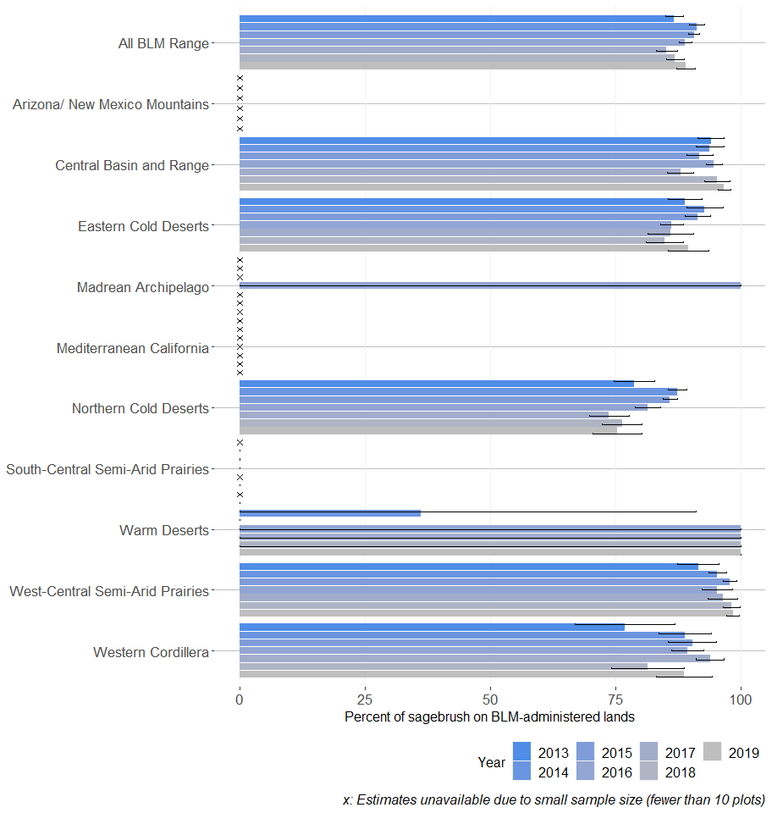

Figure 30: Mean herbaceous plant species height in inches on BLM rangelands (80% confidence interval)
## Warning: Removed 22 rows containing missing values (geom_bar).
## Warning: Removed 54 rows containing missing values (geom_point).
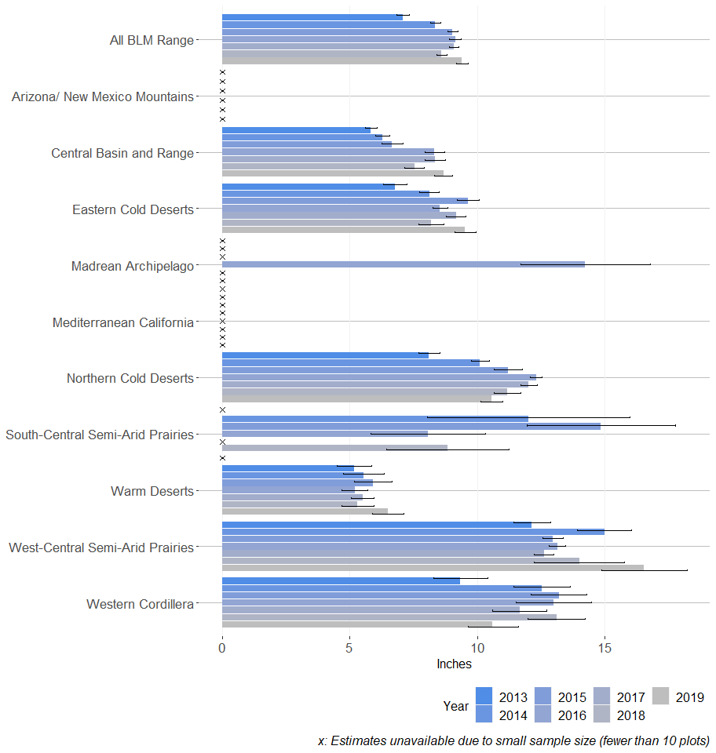

Figure 31: Percent cover of perennial grasses and perennial forbs on BLM rangelands (80% confidence interval)
## Warning: Removed 22 rows containing missing values (geom_bar).
## Warning: Removed 54 rows containing missing values (geom_point).
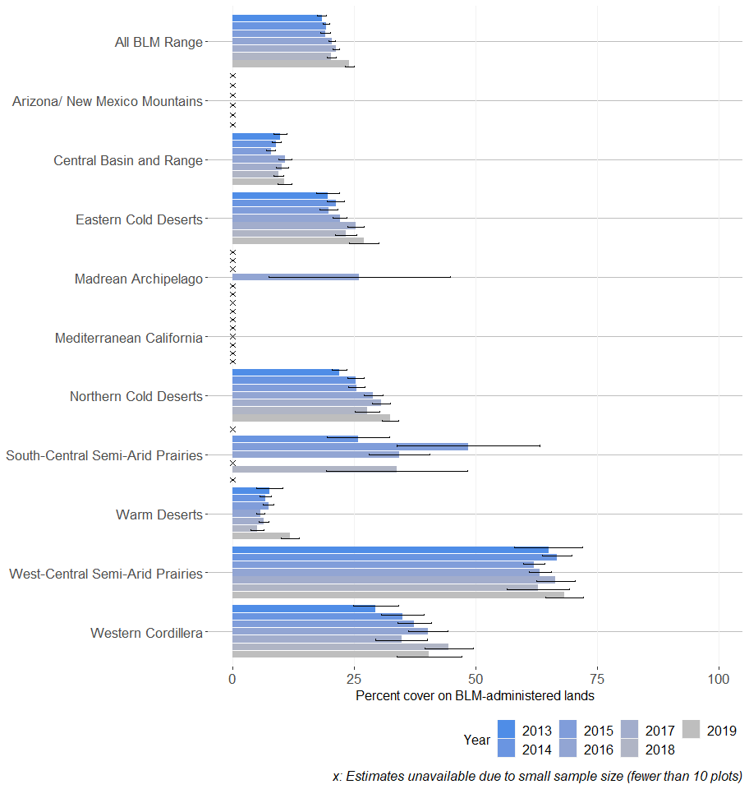

Figure 32: Percent cover of bare ground on BLM rangelands (80% confidence interval)
## Warning: Removed 22 rows containing missing values (geom_bar).
## Warning: Removed 54 rows containing missing values (geom_point).
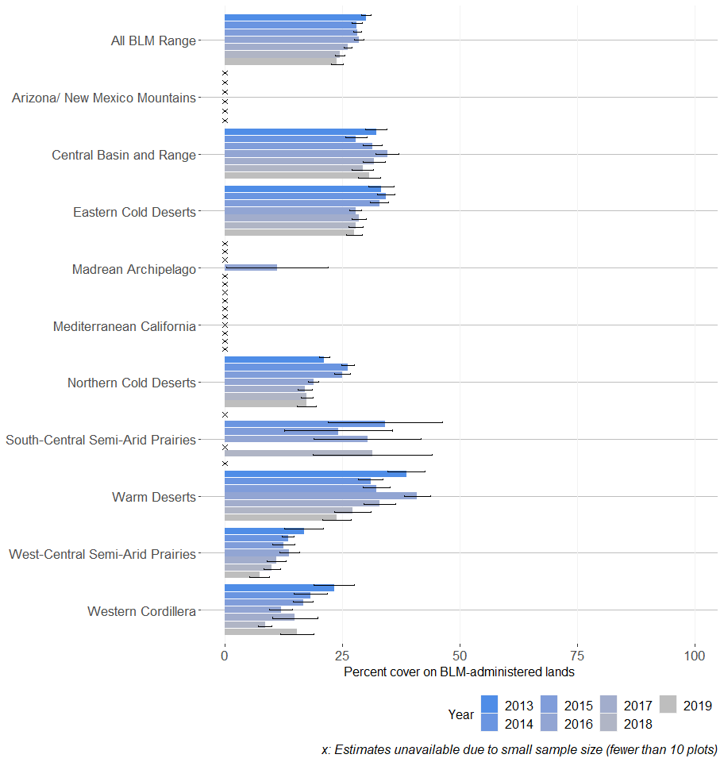

Figure 33: Proportion of vegetation composed of annual grasses on BLM rangelands (80% confidence interval)
## Warning: Removed 22 rows containing missing values (geom_bar).
## Warning: Removed 54 rows containing missing values (geom_point).
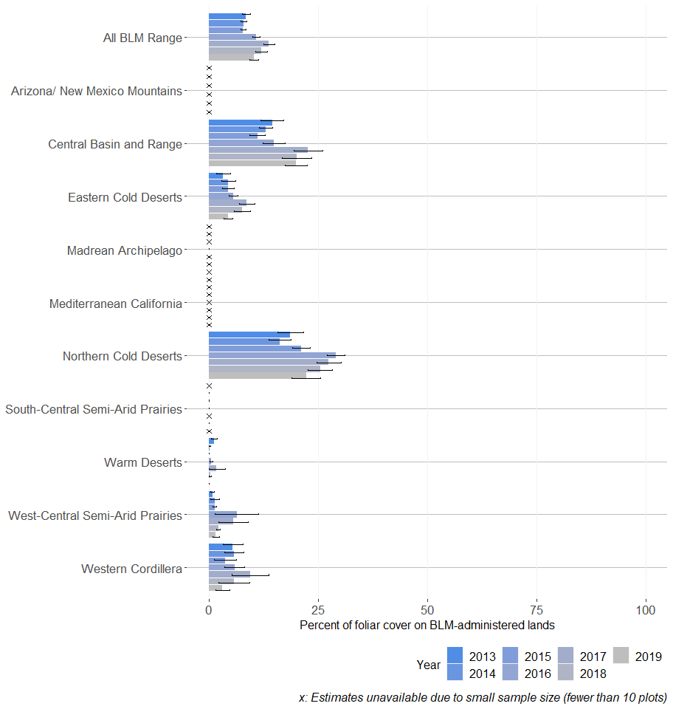

Figure 34: Proportion of vegetation composed of non-native invasive plant species on BLM rangelands (80% confidence interval)
## Warning: Removed 22 rows containing missing values (geom_bar).
## Warning: Removed 54 rows containing missing values (geom_point).
